Q1. Does assigning a value to a string&#39;s indexed character violate Python&#39;s string immutability?
Ans: it violates the immutability:
string = "My name"
string[1] = 'l'
---------------------------------------------------------------------------
TypeError Traceback (most recent call last)
Input In [91], in <cell line: 2>()
1 string = "My name"
----> 2 string[1] = 'l'

TypeError: 'str' object does not support item assignment

Q2. Does using the += operator to concatenate strings violate Python&#39;s string immutability? Why or why not?
Ans: doesn’t violates the immutability
string = 'I like '
X = 'banana'
string += X
string
output: I like banana'
‘=’ operator assign the string to a variable and + operator performs concatenation of the strings

Q3. In Python, how many different ways are there to index a character?
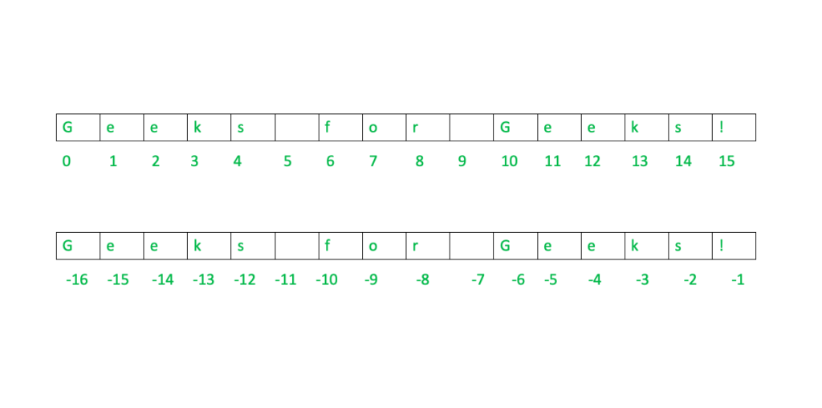
Ans: Two ways:
1. by positive index number
2. negative index number

Q4. What is the relationship between indexing and slicing?
Ans: “Indexing” means referring to an element of an iterable by its position with in iterable.
“Slicing” means getting a subset of elements from an iterable based on their indices.

Q5. What is an indexed character&#39;s exact data type? What is the data form of a slicing-generated substring?
Ans: Indexes in slicing are integer specifying the position of the elements in the iterable.
The data form fo slicing generated as substring of the string is str.

Q6. What is the relationship between string and character &quot;types&quot; in Python?
Ans: In python single character and string/ text are type: str only
character can be considered as a single index string e.g. x = “Name”
char = x[<int>]
Q7. Identify at least two operators and one method that allow you to combine one or more smaller
strings to create a larger string.
Ans: using + operator and % operator, join() and format method, using comma.

Q8. What is the benefit of first checking the target string with in or not in before using the index
method to find a substring?
Ans: the index() method ‘raises an exception’ if value is not found

Q9. Which operators and built-in string methods produce simple Boolean (true/false) results?
Ans :’And’ and ‘or’ operators applied to string produce Boolean results
input | output
str1 = ""  str2 = "python"  print(1, repr(str1 and str2))  print(2, repr(str2 and str1))  print(3, repr(str1 or str2))  print(4, repr(str2 or str1))  str1 = "Hello "  print(5, repr(str1 and str2))  print(6,repr(str2 and str1))  print(7,repr(str1 or str2))  print(8,repr(str2 or str1))  print(9,repr(not str1))  str2 = ""  print(10,repr(not str2))  str2 = "hello"  print(11, "Hello == hello: ", str1 == str2) | 1 ''  2 ''  3 'python'  4 'python'  5 'python'  6 'Hello '  7 'Hello '  8 'python'  9 False  10 True  11 Hello == hello: False

